


HerKey - AWS to GCP Migration
Knowledge Transfer

Prepared by-
Indumathi
Prachi
Harikrishnan
Reviewed by-
Premkumar

Table of Contents
Networking 3
VPC Network 3
Subnets 3
S3 Bucket migration 4
RDS MySQL to Cloud SQL using GCP Database Migration Service 6
VM MIGRATION 8
MIGRATE AWS VM TO GCP: 8
CONFIGURE THE FIREWALLS TO THE VMS 11
Convert Lambda Code to HTTP Service 13
1. Configure Environment Variables 15
2. Replace AWS Triggers with GCP Services 16
3. Setup IAM Permissions 16
4. Logging and Monitoring 16
5. Testing the Migration 17
6. Recommended Configuration 17
Cloud Armor Policy Setup 18

Networking
VPC Network
- One VPC network created with 6 subnets
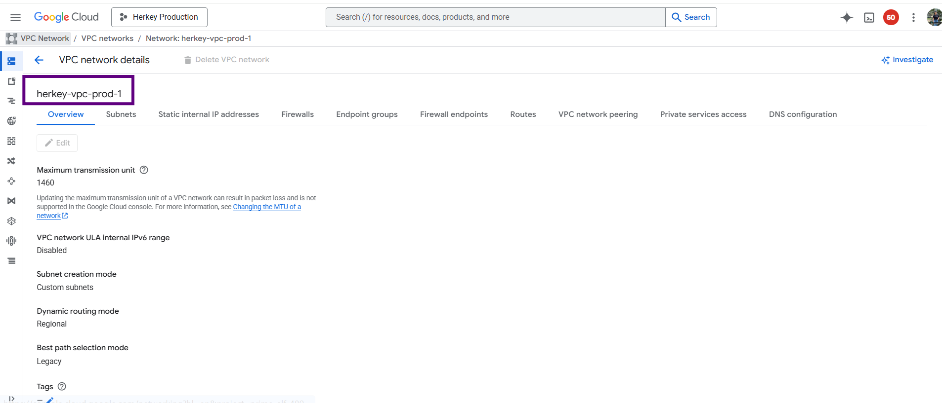

Subnets
- 2 subnets created in asia-south-1 region with a range of
- private subnets - 10.50.16.0/20 and public subnets - 10.50.0.0/20
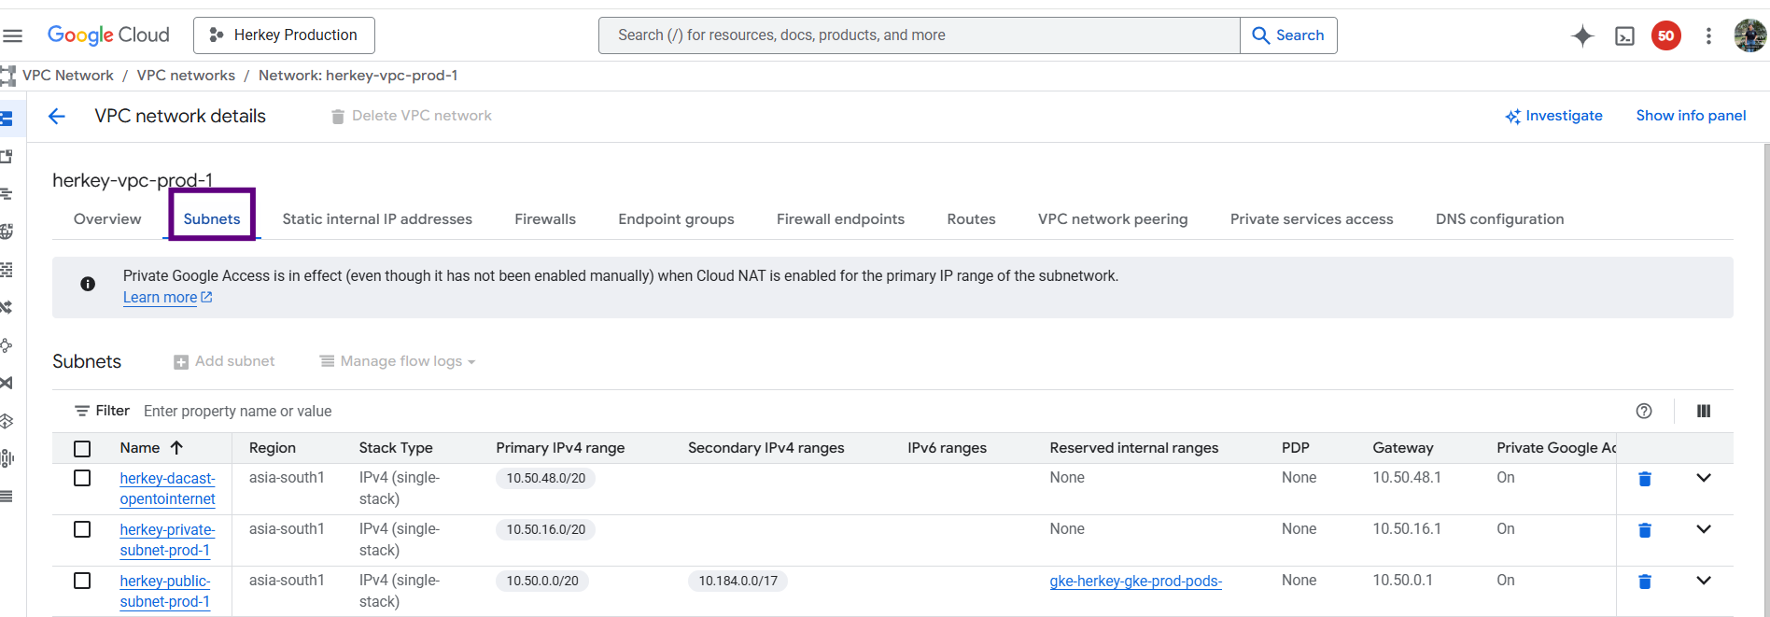

S3 Bucket migration
- For S3 migration, we used Storage Transfer Service
- Migrated AWS S3 buckets to Google Cloud Storage
- When we start create storage transfer job, first select the source type Amazon S3 and the destination type is Google Cloud Storage
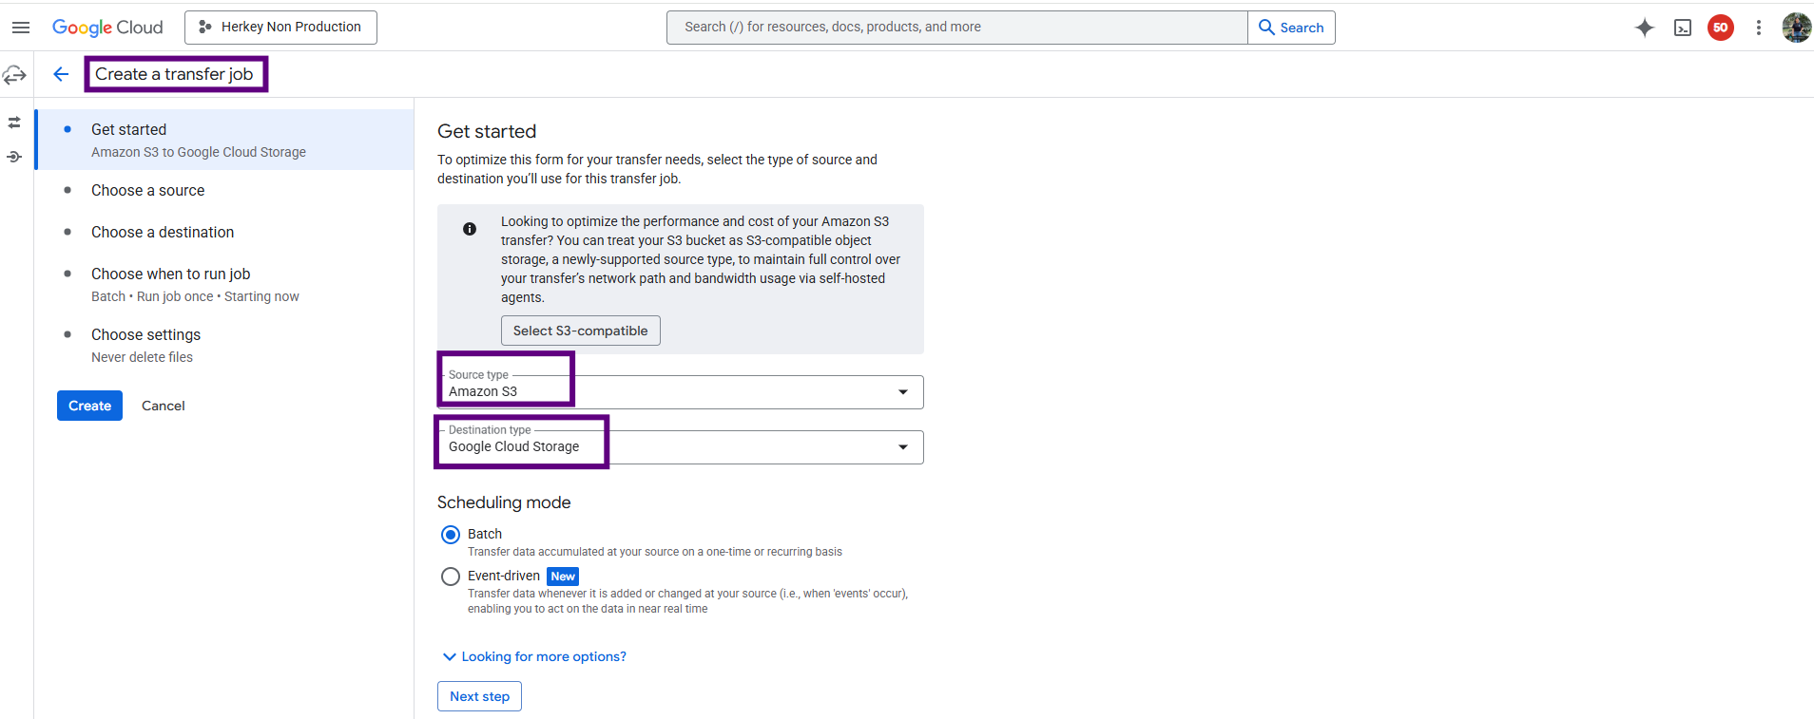
For the source, you need to specify source details
Bucket name - ABC
Credentials: Access key and secret key
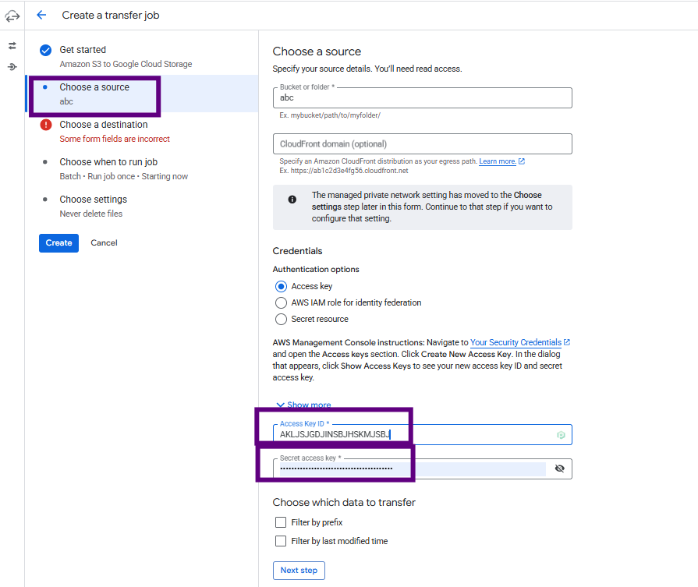

- After that, select the destination details like the bucket name
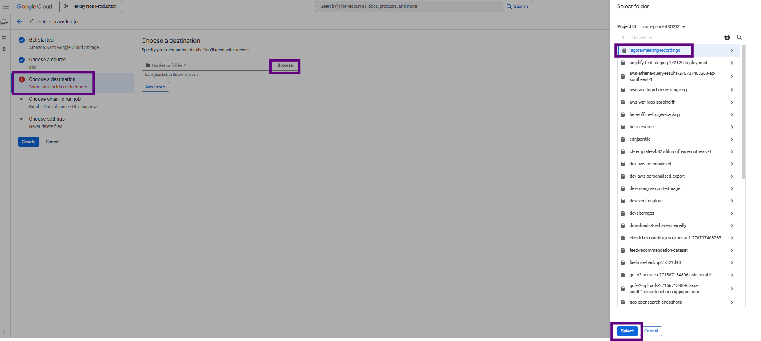
- Choose the run job type
- Then create a transfer job
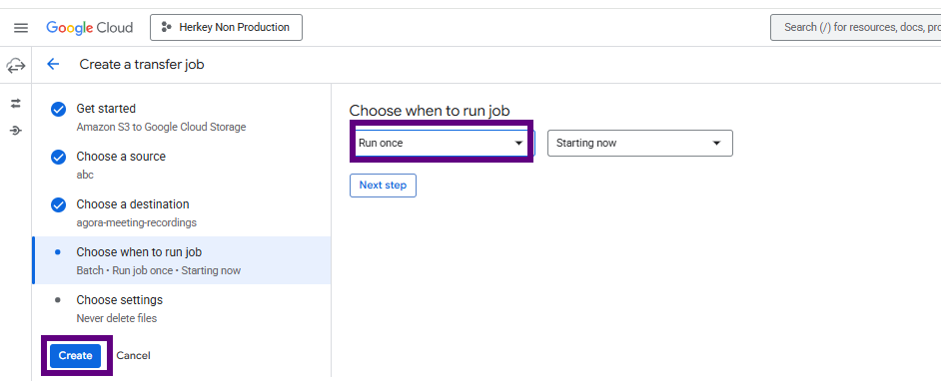
- After creating the job, run the job it will migrate bucket aws to gcp
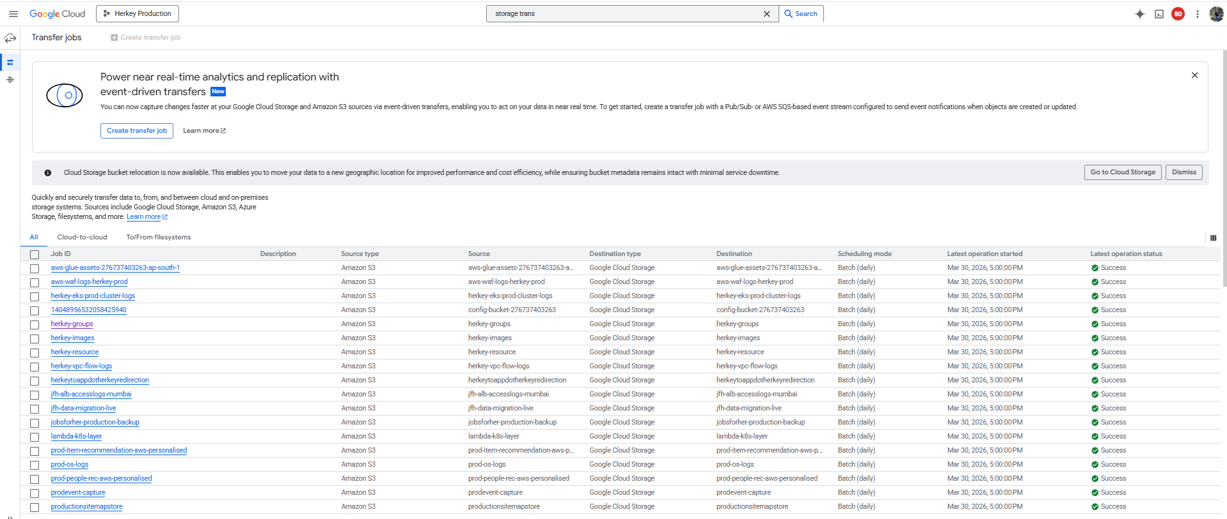

x`RDS MySQL to Cloud SQL using GCP Database Migration Service
Pre-migration requirements
- Ensure RDS MySQL version is supported by Cloud SQL
- Enable binary logging on Amazon RDS:
  - binlog_format = ROW
  - binlog_row_image = FULL
- Set binlog retention > migration duration
- Create a migration user in RDS with required privileges
Create Cloud SQL (MySQL) instance
- Create a Cloud SQL for MySQL instance in GCP
- Use the same or higher MySQL version
- Configure region, machine type, and storage
- Do not create databases/tables manually
Configure network connectivity
- Ensure DMS can reach RDS:
  - Allow RDS Security Group inbound access
  - Whitelist DMS public IPs or use VPC peering
- Open MySQL port 3306
Create Database Migration Service profile
- In GCP Console → Database Migration
- Create a Source connection profile:
  - Engine: MySQL
  - Endpoint: RDS endpoint
  - Username & password
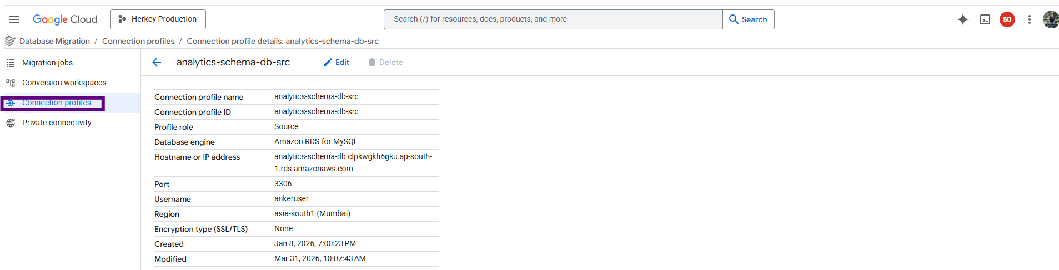
- In destination section add sql details :
  - Select the Cloud SQL instance
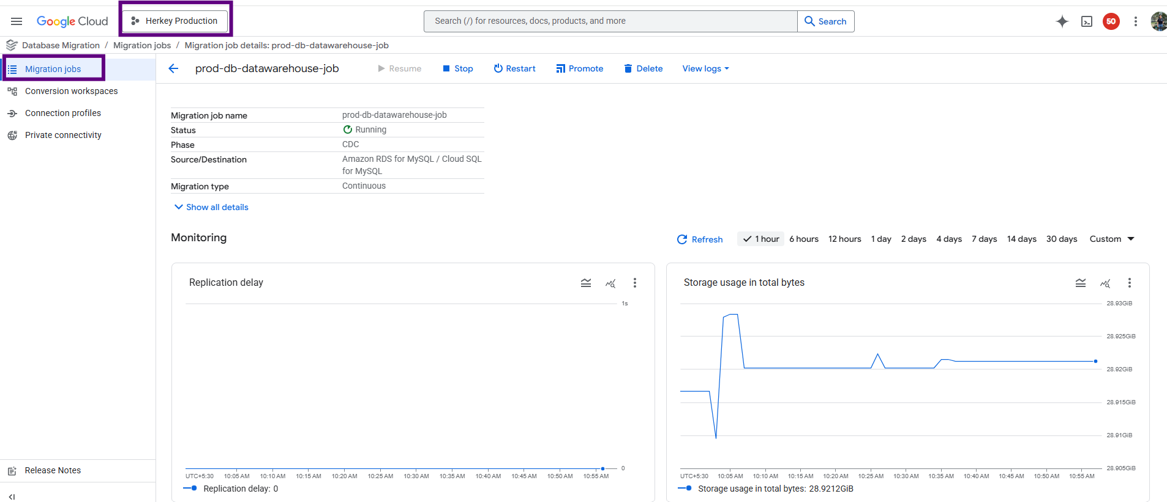
Start migration
- DMS performs:
  - Initial full data load
  - Ongoing replication using binlogs
- Monitor status in GCP Console
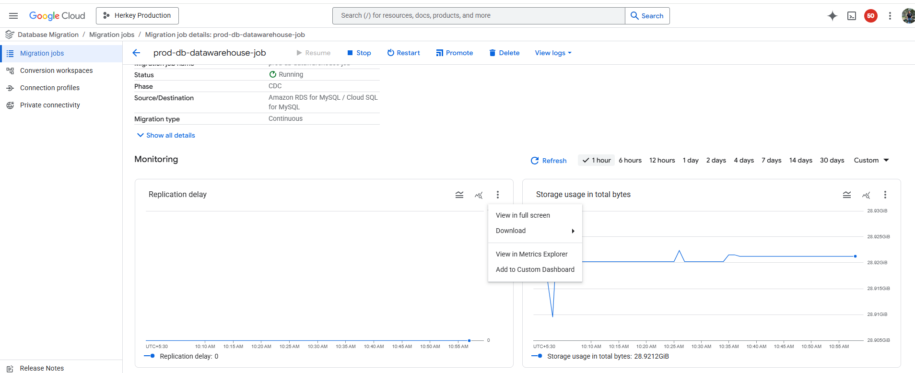
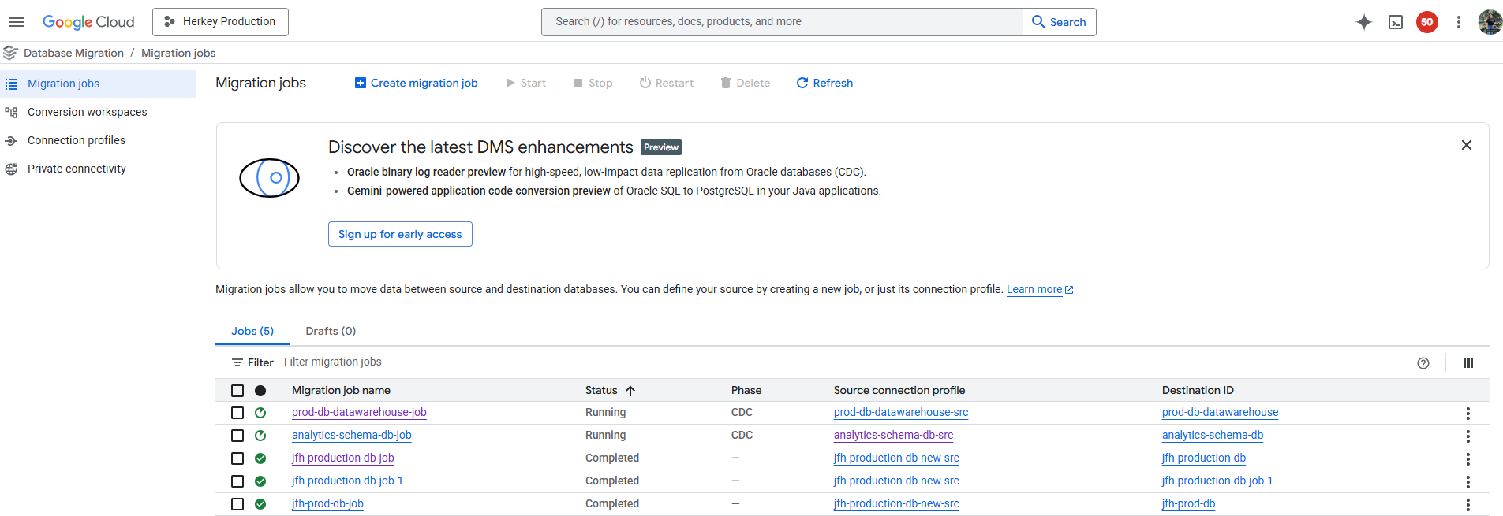

VM MIGRATION
MIGRATE AWS VM TO GCP:
- In Google Cloud Console,
Go to the Compute Engine -> Migrate to Virtual Machine and select the source section then click on Add Source -> +Add AWS Source.
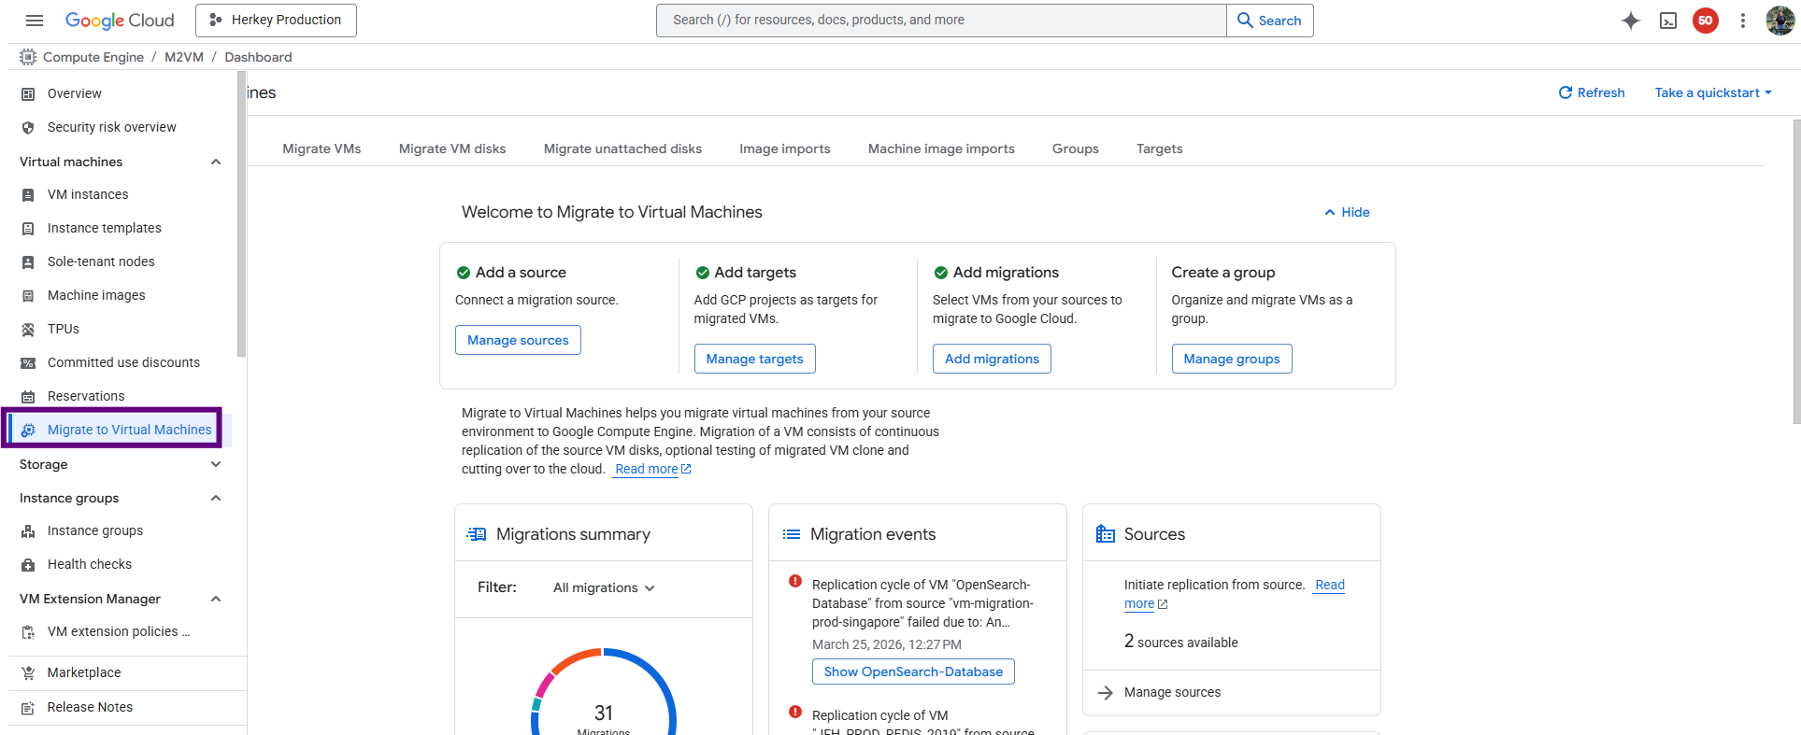
- Provide the AWS Access Key ID and Secret access key and Click create. And Waiting for a few minutes when the source is active. And then you will see AWS EC2 Instance in GCP.
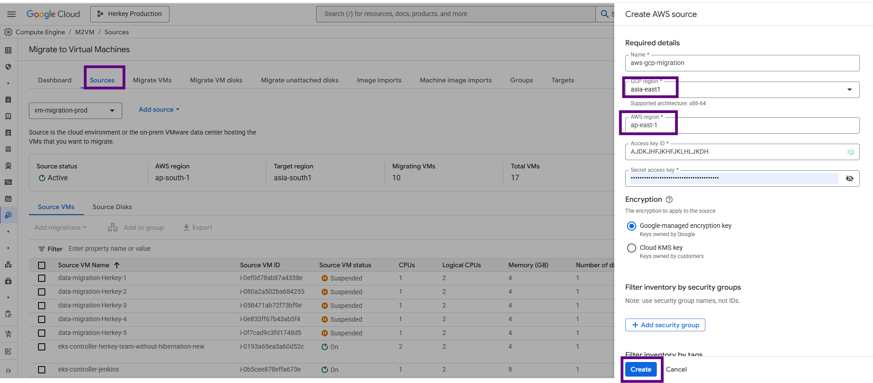
- Select the VM from list whose disk you wants to migrate, and click add migration->VM or disk migration

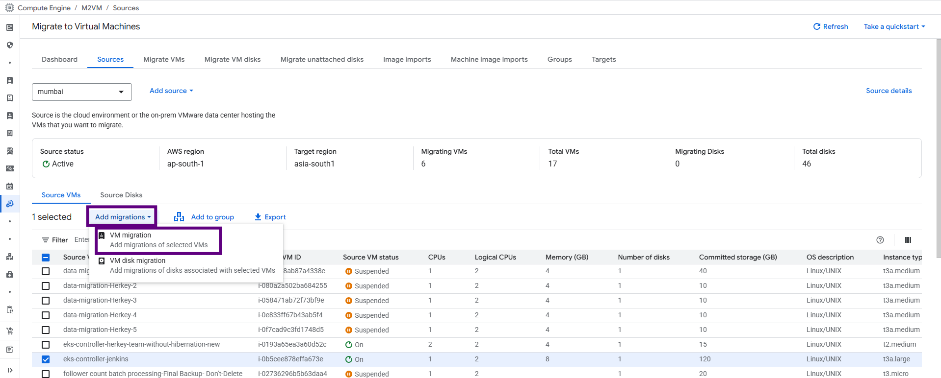
- Go to the Migration Section. Here you see the Migration VM and select the source VM and then Click on Edit Target Details
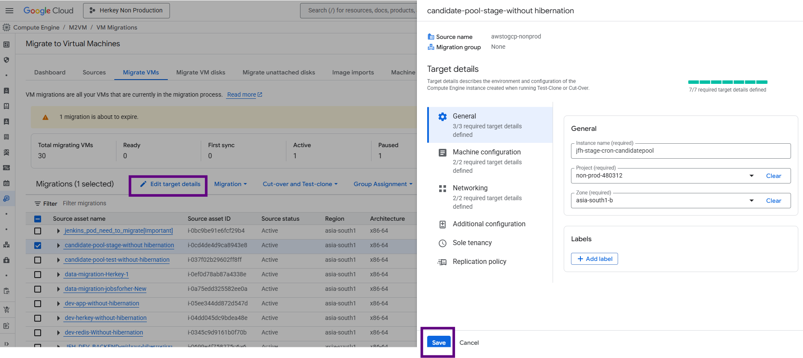
- Provide the 7 required details for creating the GCP VM like — Instance Name, Project, Zone, machine type series, machine type, network, subnetwork.
- Select Migration and Start the replication. Wait for a few minutes….
- Whenever It’s Active mode click CUT-OVER AND TEST-CLONE and run the test clone
- Verified the Test Clone is Completed
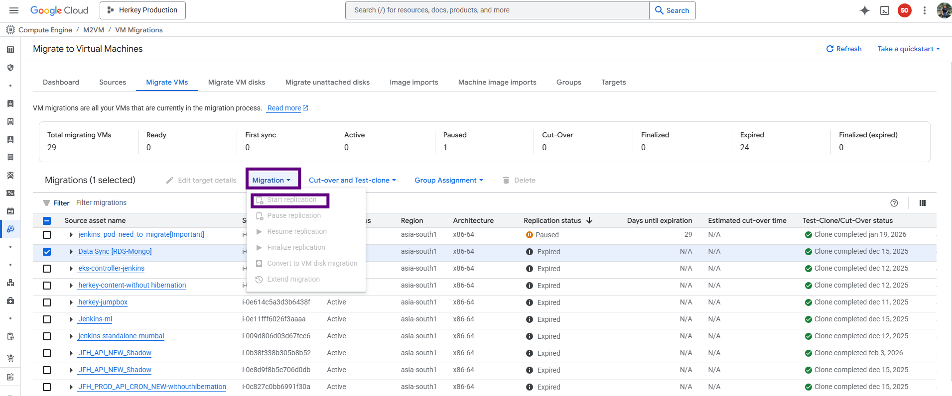
- Now Your Migrated VM is Ready clone the vm and you are able to see vm in compute machine section
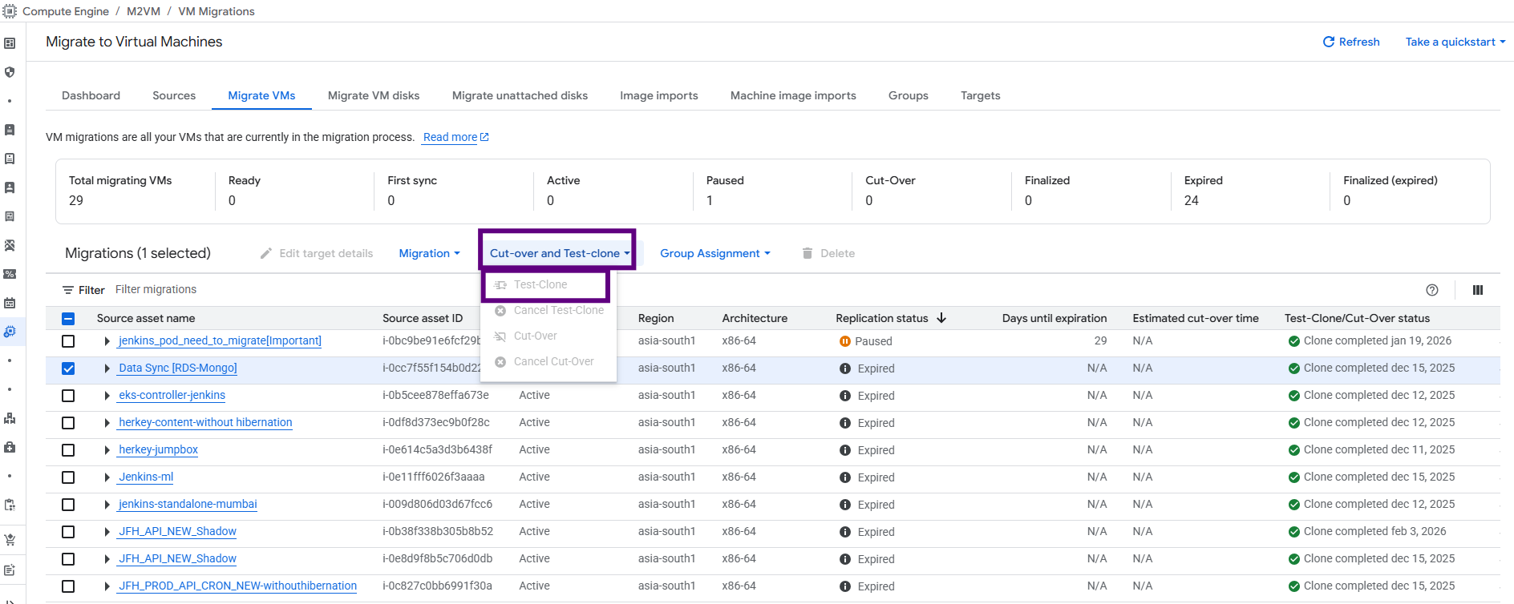

- VM in compute section
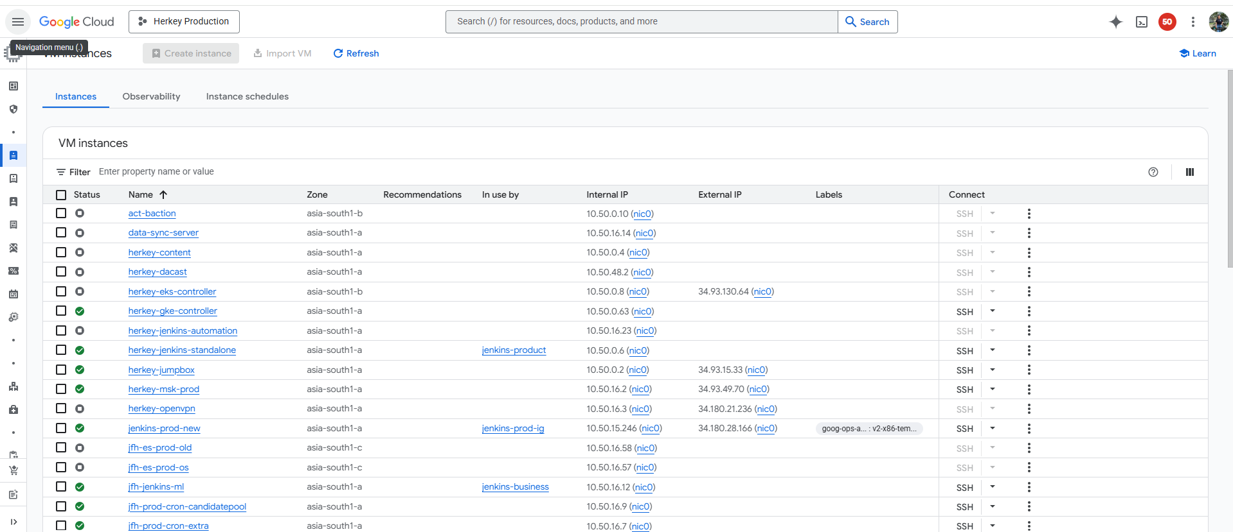

CONFIGURE THE FIREWALLS TO THE VMS
- Create Firewall Rules with specified target tag:
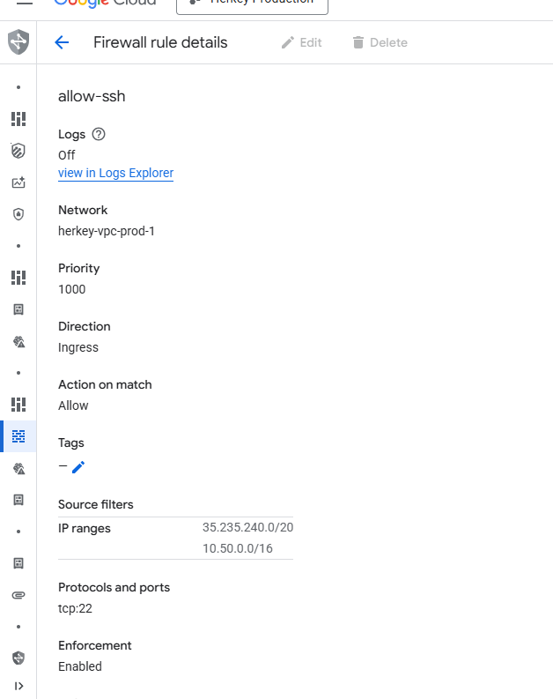

- Once created Edit the instance and add the network tags and save it.
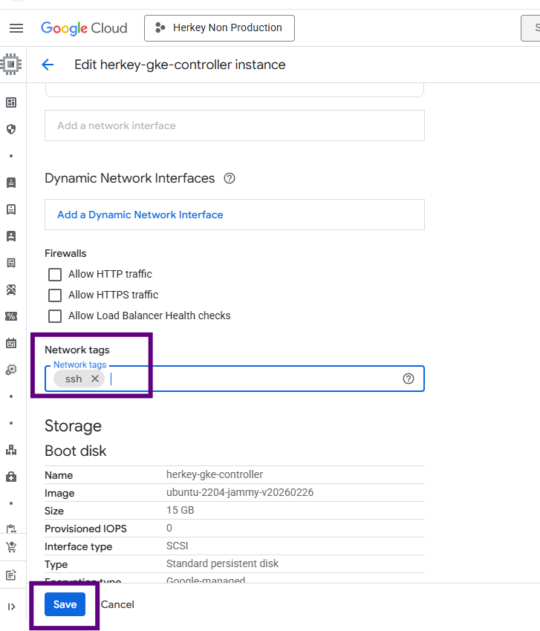

Cloud Run Function
Collect Information from Existing Lambda
- Before migrating, gather the following information:
- Lambda function name
- Runtime (Python / Node.js / Java etc.)
- Environment variables
- Dependency libraries
- IAM permissions
- Trigger type (API Gateway, S3, Scheduler, SNS, SQS)
Convert Lambda Code to HTTP Service
- Cloud Run requires an HTTP application
Via CLI
Deploy the container if we are using docker images
gcloud run deploy lambda-migrated-service --image us-central1-docker.pkg.dev/PROJECT_ID/cloud-run-repo/lambda-migrated --platform managed --region us-central1 --allow-unauthenticated

- If we are writing a function use this cmd
gcloud functions deploy function_name \
--runtime python311 \
--region asia-south1 \
--trigger-http \
--allow-unauthenticated \
--service-account cloudrun-sa@non-prod-480312.iam.gserviceaccount.com \
--memory 512MB \
--entry-point function_name
- After deployment Cloud Run provides a service URL which can be used to access the application.
- 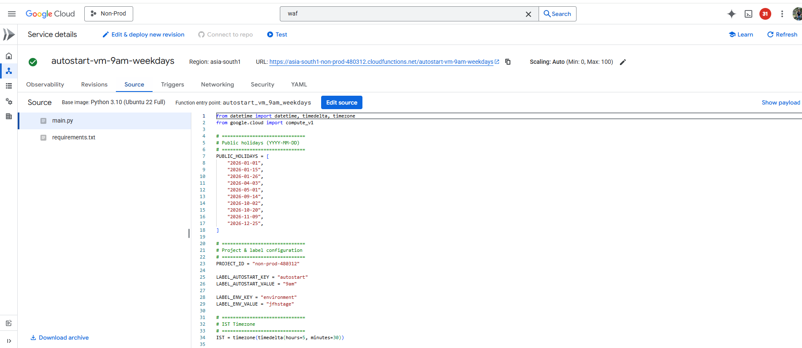
If you wants to create a scheduler we can use this commands
gcloud scheduler jobs create http function_name --schedule="0 9 * * 1-5" --uri="https://asia-south1-non-prod-480312.cloudfunctions.net/function_name" --http-method=POST --time-zone="Asia/Kolkata" --location=asia-south1
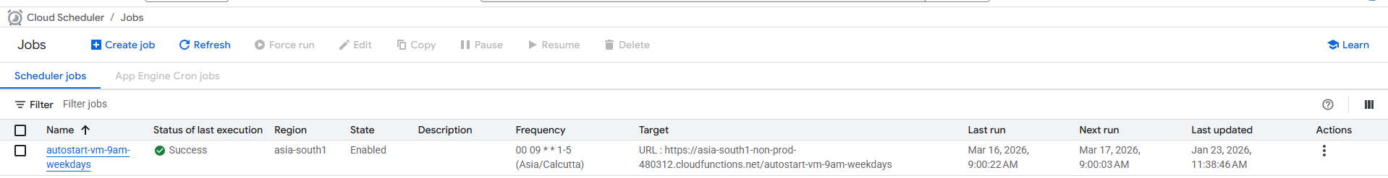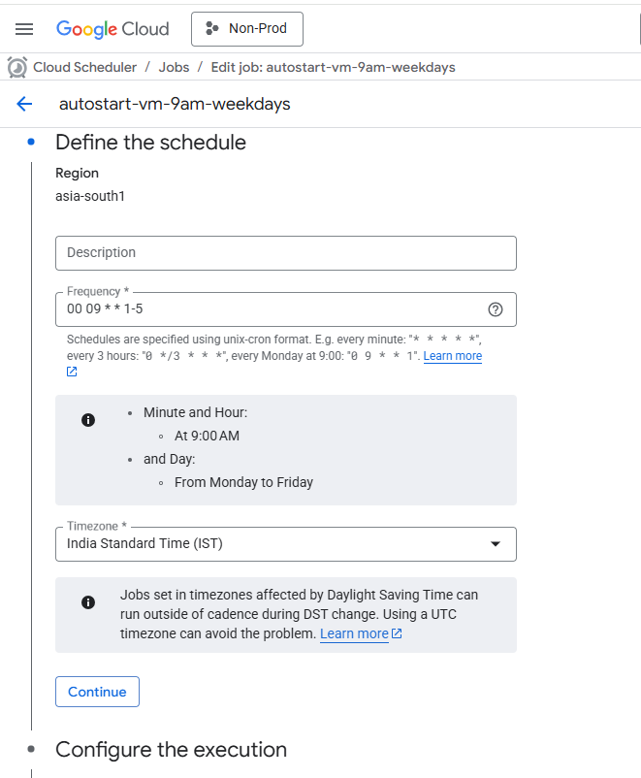
- Configure Environment Variables
If Lambda used environment variables such as:
DB_HOST
API_KEY
Deploy using - gcloud run deploy SERVICE_NAME --image IMAGE_URL --set-env-vars DB_HOST=value,API_KEY=value
- Replace AWS Triggers with GCP Services
- AWS Service -> Google Cloud Equivalent
- API Gateway -> Cloud Run HTTP Endpoint
- CloudWatch Scheduler -> Cloud Scheduler
- S3 Events -> Cloud Storage Events
- SNS -> Pub/Sub
- SQS -> Pub/Sub
- Setup IAM Permissions
- Create a Service Account in Google Cloud.
- Assign roles such as:
  - Cloud Run Invoker
  - Storage Object Viewer
  - Pub/Sub Subscriber
- Attach the service account to the Cloud Run service.
- Logging and Monitoring
- AWS Lambda uses CloudWatch Logs.
- Cloud Run uses Cloud Logging.
- Steps:
  - Open Cloud Run service
  - Click Logs
  - View request logs and container logs
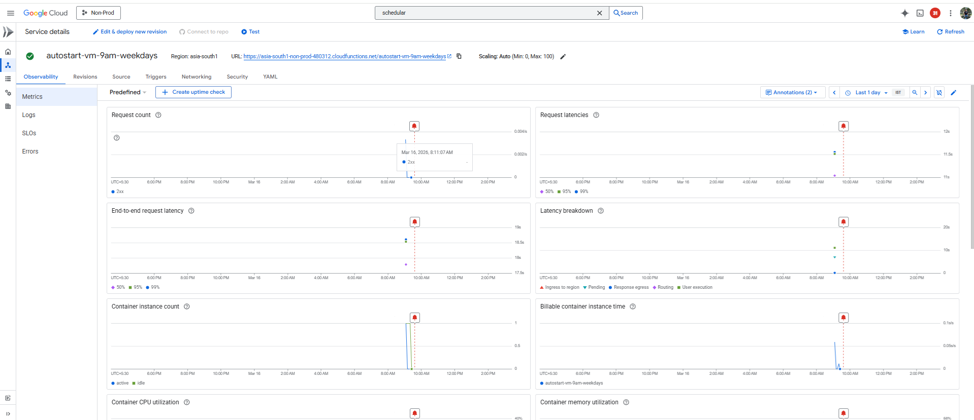
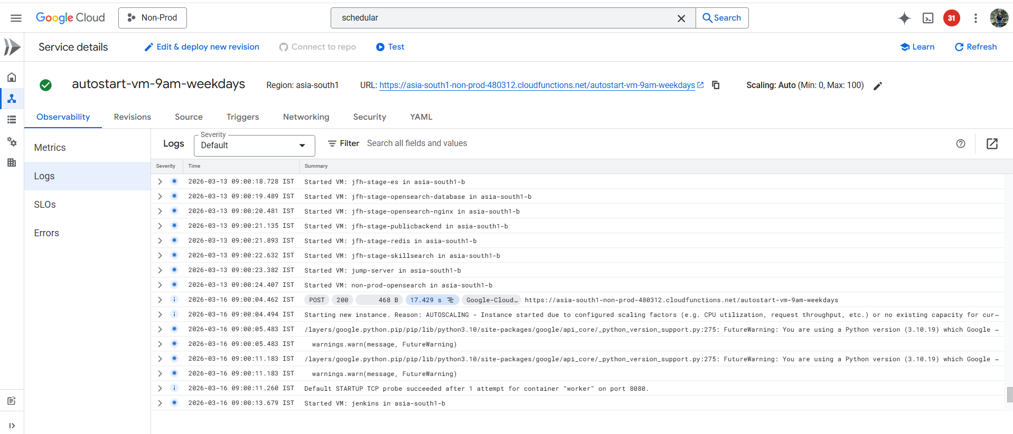
- Testing the Migration
- Test the deployed service.
- Using curl - curl https://SERVICE_URL
- Verify:
  - Correct response
  - Logs are generated
  - Scaling works correctly
- Recommended Configuration
Suggested Cloud Run settings:
- Memory: 512MB – 1GB
- CPU: 1
- Concurrency: 80
- Timeout: 300 seconds
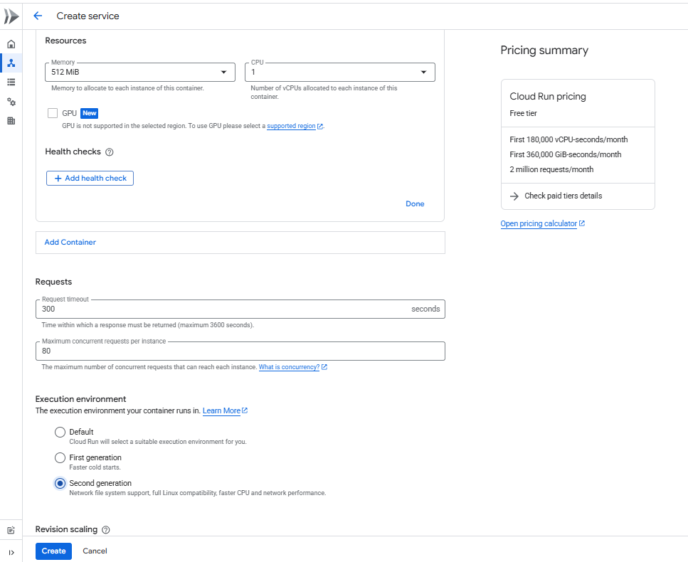

Cloud Armor Policy
- Go to the cloud armor service in the GCP console and create a new policy.
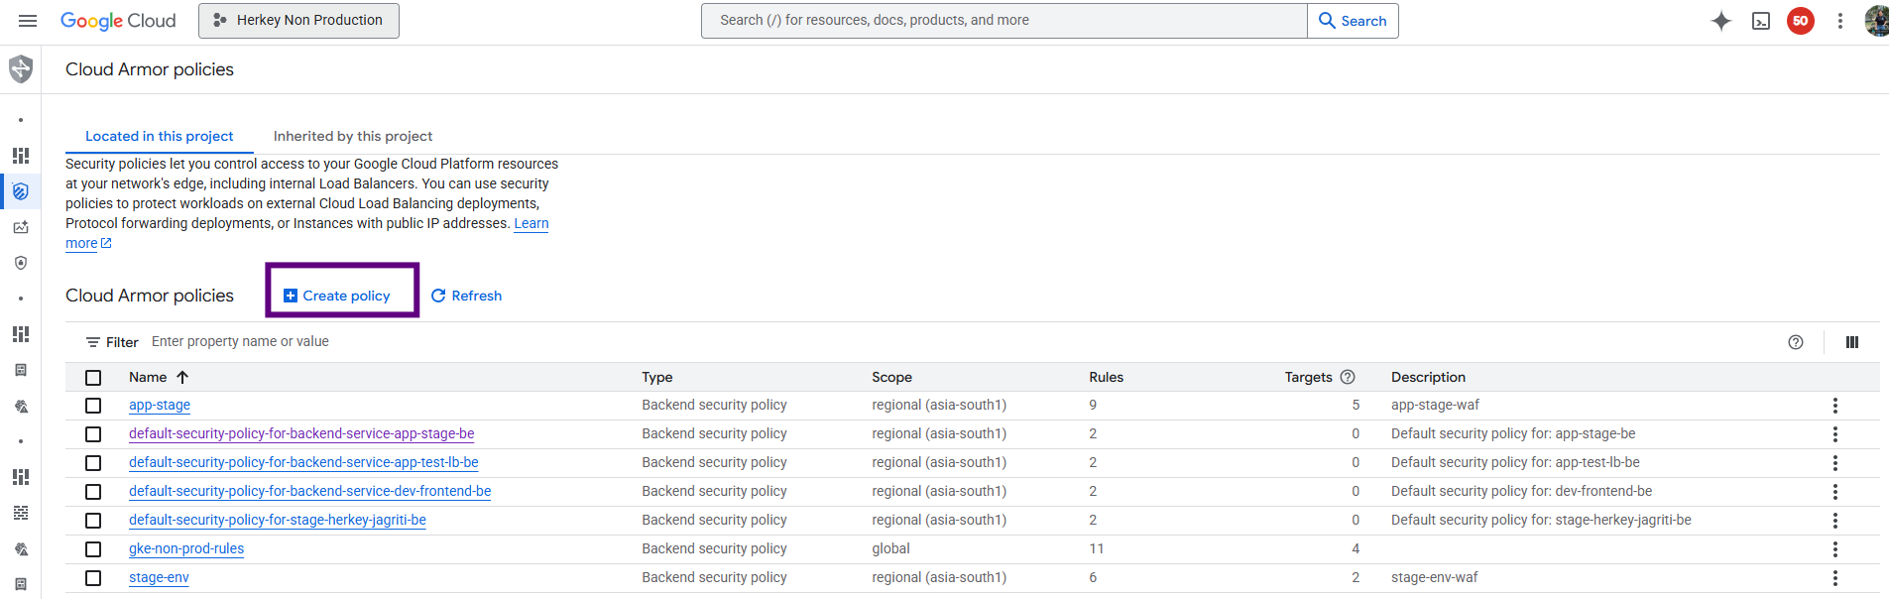
- Give the name of the policy and keep the rest options as it is.

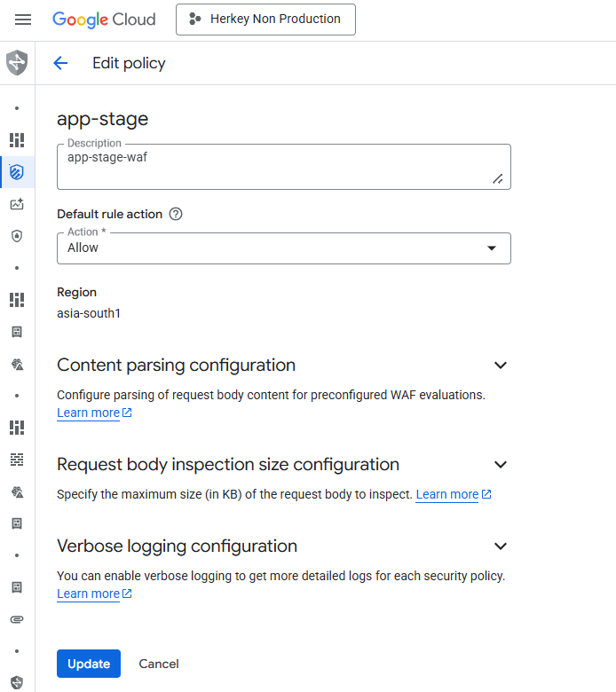
- Skip the rule part and to go the target part. Add the target which is the load balancer backend type. Give the backend as the frontend service that is running on cloud run.

- Save the policy.

- Open the policy edit the default policy and change the deny rule to allow.
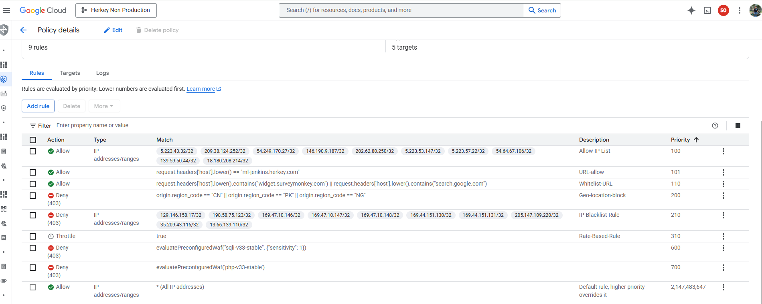
- Add new rules to the policy by clicking on the add rules button.

- Add the description of the rule that is to be applied and under the condition select advance mode. Under the matchbox dialog box write the rule name and select the equivalent preconfigured rule.

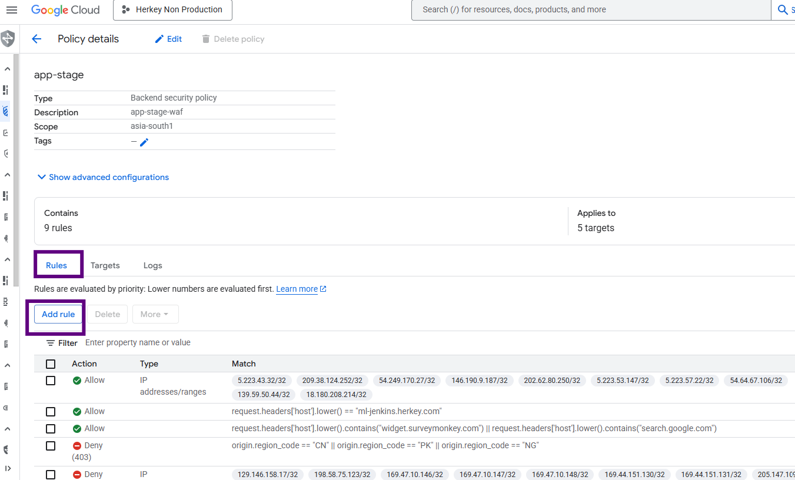
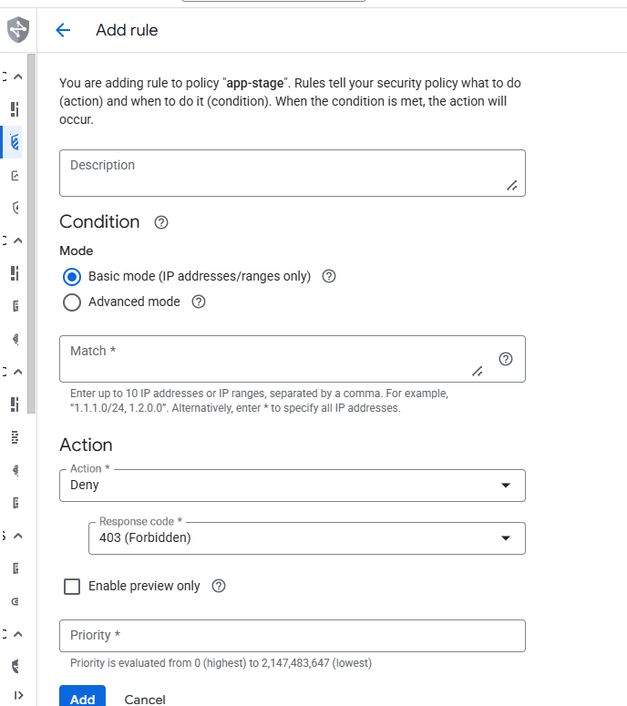
- If the preconfigured rule is not visible then follow the below document.
Cloud Armor preconfigured WAF rules overview

- Add all the below rules one by one with priority starting from 20000 (you can give any number other than 20000)

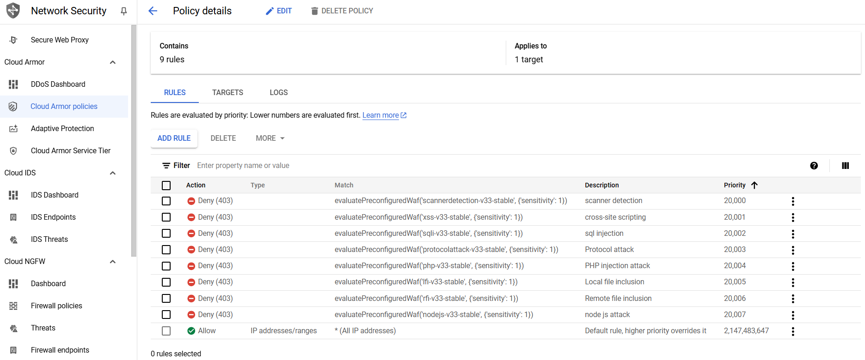

- Check the load balancer metadata if the policy is attached or not.
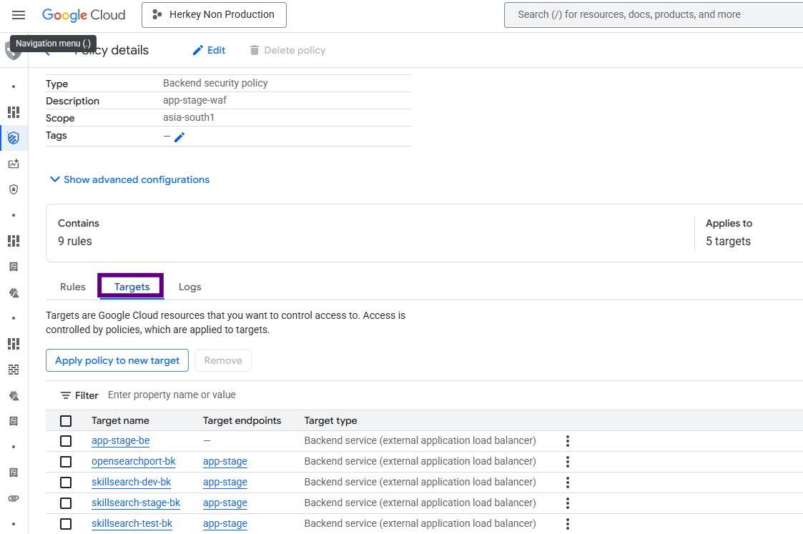

Migration OpenSearch from AWS

Overview
This section describes the migration of OpenSearch data from AWS to GCP using the snapshot and restore mechanism. The migration leverages Google Cloud Storage (GCS) as an intermediate storage layer and a self-managed OpenSearch instance running on a GCP VM.

Architecture Flow
AWS OpenSearch snapshots are copied to a GCS bucket. The GCP OpenSearch instance is configured with the GCS repository plugin to access these snapshots and restore the indices.

Prerequisites

GCP VM Configuration
Machine Type: e2-standard-4 or higher
Disk Size: Minimum 200 GB SSD
Operating System: Ubuntu 20.04 or 22.04

Network Configuration
Port 9200: OpenSearch API access
Port 5601: OpenSearch Dashboards (optional)

IAM Roles
Storage Object Viewer: Required to read snapshots
Storage Object Admin: Required if writing snapshots

Install Java
Run the following commands to install Java:

apt update
apt install -y openjdk-17-jdk
java -version

Install OpenSearch
Download and extract OpenSearch:

cd /usr/local
wget https://artifacts.opensearch.org/releases/bundle/opensearch/2.19.4/opensearch-2.19.4-linux-x64.tar.gz
tar -xzf opensearch-2.19.4-linux-x64.tar.gz
mv opensearch-2.19.4 opensearch

Create OpenSearch User
useradd opensearch
chown -R opensearch:opensearch /usr/local/opensearch

6.7 Configure OpenSearch
Edit the configuration file:
vi /usr/local/opensearch/config/opensearch.yml
Add the following configuration:

cluster.name: gcp-nonprod-os
node.name: gcp-node-1
network.host: 0.0.0.0
http.port: 9200
discovery.type: single-node
plugins.security.disabled: true

Security is disabled only for non-production environments. Credentials must not be stored in this file.

6.8 Install GCS Repository Plugin
sudo -u opensearch /usr/local/opensearch/bin/opensearch-plugin install repository-gcs

6.9 Configure GCS Credentials
Create directory and copy key file:
mkdir -p /etc/opensearch
cp gcs-key.json /etc/opensearch/
chown opensearch:opensearch /etc/opensearch/gcs-key.json
chmod 600 /etc/opensearch/gcs-key.json
Add credentials to keystore:
sudo -u opensearch /usr/local/opensearch/bin/opensearch-keystore create

sudo -u opensearch /usr/local/opensearch/bin/opensearch-keystore add-file \
gcs.client.default.credentials_file /etc/opensearch/gcs-key.json

6.10 Configure OpenSearch as systemd Service
Create the service file:

sudo tee /etc/systemd/system/opensearch.service <<EOF
[Unit]
Description=OpenSearch
After=network-online.target

[Service]
User=opensearch
Group=opensearch
ExecStart=/usr/local/opensearch/bin/opensearch
Restart=always
LimitNOFILE=65535
LimitMEMLOCK=infinity

[Install]
WantedBy=multi-user.target

EOF

Enable and start the service:
systemctl daemon-reexec
systemctl daemon-reload
systemctl enable opensearch
systemctl start opensearch
Verify:
systemctl status opensearch
curl http://localhost:9200

6.11 Verify GCS Plugin
curl http://localhost:9200/_cat/plugins?v
Ensure repository-gcs is listed.

6.12 Register Snapshot Repository
curl -X PUT "http://localhost:9200/_snapshot/candidatepooluat_repo" \
-H "Content-Type: application/json" \
-d '{
"type": "gcs",
"settings": {
"bucket": "gcp-opensearch-snapshots",
"base_path": "snapshot/candidatepooluat",
"client": "default"
}
}'
Verify repository:
curl http://localhost:9200/_snapshot/candidatepooluat_repo/_all?pretty

6.13 Verify Available Snapshots
curl http://localhost:9200/_snapshot?pretty

6.14 Cleanup Existing Indices (Optional)
Delete specific indices if required:
curl -X DELETE "http://localhost:9200/index-name"
Avoid deleting all indices without validation.

6.15 Restore Snapshot
Restore all indices:
curl -X POST "http://localhost:9200/_snapshot/candidatepooluat_repo/candidatepooluat-snap-01/_restore" \
-H "Content-Type: application/json" \
-d '{
"indices": "*",
"rename_pattern": "(.+)",
"rename_replacement": "candidate-pool-uat-$1",
"include_global_state": false,
"index_settings": {
"index.number_of_replicas": 0
}
}'
Restore specific indices:
"indices": "index1,index2"
Index renaming is used to avoid conflicts. Replica count is set to zero to improve restore performance.

6.16 Monitor Restore Progress
curl http://localhost:9200/_snapshot/candidatepooluat_repo/candidatepooluat-snap-01/_status?pretty
watch -n 10 'curl -s http://localhost:9200/_cluster/health?pretty'

6.17 Validate Restored Data
curl http://localhost:9200/_cat/indices?v
curl http://localhost:9200/index-name/_count?pretty

6.18 Post Restore Configuration
curl -X PUT "http://localhost:9200/candidate-pool-uat-*/_settings" \
-H "Content-Type: application/json" \
-d '{"index.number_of_replicas": 1}'

6.19 Access OpenSearch
Access from browser:
http://<VM-IP>:9200/_cat/indices?v

7. GKE Autopilot Cluster
GKE Autopilot provides a managed Kubernetes environment with automatic node provisioning, scaling, and security enforcement. It eliminates the need to manage node pools, reduces operational overhead, and enforces best practices such as resource requests and limits.

7.1 Create GKE Autopilot Cluster
- Go to Console → Kubernetes Engine → Clusters → CREATE.
- Select Autopilot mode (recommended).
- Cluster basics:
  - Name: herkey-gke-prod
  - Region: asia-south1
  - Networking: choose your project VPC and subnets.
- Click Create.
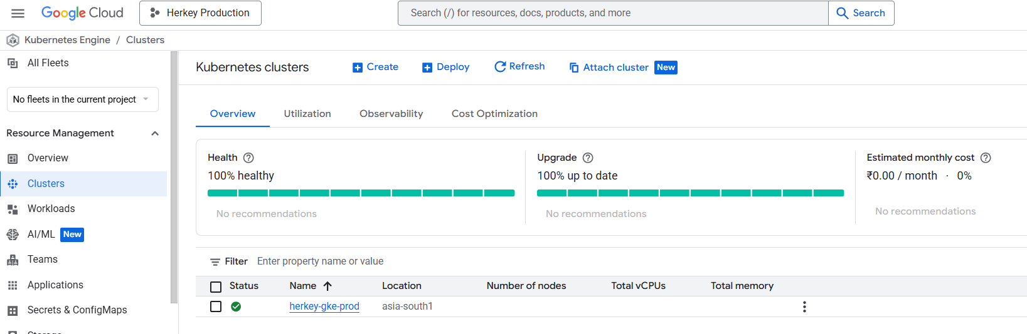

7.2 Namespace Creation
Create required namespaces for workloads:

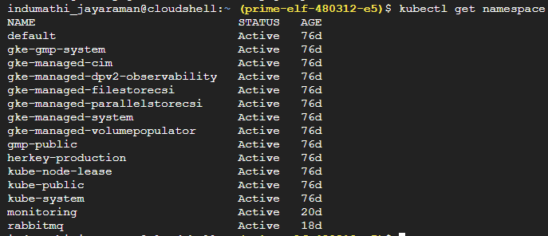

7.3 Ingress
Expose services using GKE Ingress:

apiVersion: networking.k8s.io/v1
kind: Ingress
metadata:
name: {{ template "herkey.fullname" . }}
namespace: {{ .Release.Namespace }}
annotations:
kubernetes.io/ingress.class: "gce"
networking.gke.io/managed-certificates: prod-ingress-cert
kubernetes.io/ingress.global-static-ip-name: "prod-gke-ingres-ip"
networking.gke.io/frontend-config: herkey-prod-backend-alb-ingress-fd
spec:
ingressClassName: gce
rules:
- host: "{{ .Values.domain }}.herkey.com"
http:
paths:
- pathType: Prefix
path: /
backend:
service:
name: {{ template "herkey.fullname" . }}
port:
number: {{ .Values.service.externalPort }}
- pathType: Prefix
path: /api/v1/herkey/signin/
backend:
service:
name: {{ .Values.service.signin }}
port:
number: {{ .Values.service.externalPort }}
- pathType: Prefix
path: /api/v1/herkey/feeds/
backend:
service:
name: {{ .Values.service.feeds }}
port:
number: {{ .Values.service.externalPort }}
- pathType: Prefix
path: /api/v1/herkey/networks/
backend:
service:
name: {{ .Values.service.networks }}
port:
number: {{ .Values.service.externalPort }}
- pathType: Prefix
path: /api/v1/herkey/gmeet/
backend:
service:
name: {{ .Values.service.gmeet }}
port:
number: {{ .Values.service.externalPort }}
- pathType: Prefix
path: /api/v1/herkey/notifications/
backend:
service:
name: {{ .Values.service.notifications }}
port:
number: {{ .Values.service.externalPort }}
- pathType: Prefix
path: /api/v1/herkey/groups/
backend:
service:
name: {{ .Values.service.groups }}
port:
number: {{ .Values.service.externalPort }}
- pathType: Prefix
path: /api/v1/herkey/direct-message/
backend:
service:
name: {{ .Values.service.dm }}
port:
number: {{ .Values.service.externalPort }}
- pathType: Prefix
path: /api/v1/herkey/companies/
backend:
service:
name: {{ .Values.service.companies }}
port:
number: {{ .Values.service.externalPort }}
- pathType: Prefix
path: /api/v1/herkey/jobs/
backend:
service:
name: {{ .Values.service.jobs }}
port:
number: {{ .Values.service.externalPort }}
- pathType: Prefix
path: /api/v1/herkey/email/
backend:
service:
name: {{ .Values.service.email }}
port:
number: {{ .Values.service.externalPort }}
- pathType: Prefix
path: /api/v1/herkey/sessions/
backend:
service:
name: {{ .Values.service.sessions }}
port:
number: {{ .Values.service.externalPort }}
- pathType: Prefix
path: /api/v1/herkey/herkeysearch/
backend:
service:
name: {{ .Values.service.userzonesearch }}
port:
number: {{ .Values.service.externalPort }}
- pathType: Prefix
path: /api/v1/herkey/herkeyrecommendations/
backend:
service:
name: {{ .Values.service.userzonesearch }}
port:
number: {{ .Values.service.externalPort }}
- pathType: Prefix
path: /api/v1/herkey/payments/
backend:
service:
name: {{ .Values.service.payments }}
port:
number: {{ .Values.service.externalPort }}
- pathType: Prefix
path: /api/v1/herkey/tracking/
backend:
service:
name: {{ .Values.service.tracking }}
port:
number: {{ .Values.service.externalPort }}
- pathType: Prefix
path: /api/v1/herkey/mobileapp/
backend:
service:
name: {{ .Values.service.mobileapp }}
port:
number: {{ .Values.service.mobileappPort}}
- pathType: Prefix
path: /api/v1/herkey/meet/
backend:
service:
name: {{ .Values.service.meet }}
port:
number: {{ .Values.service.meetPort }}

#flower-ingress
- host: "{{ .Values.flower.domain }}.herkey.com"
http:
paths:
- pathType: ImplementationSpecific
path: /*
backend:
service:
name: {{ template "herkey.fullname-flower" . }}
port:
number: {{ .Values.flower.externalPort }}

#frontend-ingress
- host: www.herkey.com
http:
paths:
- pathType: Prefix
path: /.well-known/
backend:
service:
name: wellknown-nginx-svc
port:
number: 80
- pathType: Prefix
path: /sitemaps
backend:
service:
name: nginx-sitemap-svc-prod
port:
number: 80
- pathType: Exact
path: /sitemap.xml
backend:
service:
name: nginx-sitemap-svc-prod
port:
number: 80
- pathType: ImplementationSpecific
path: /*
backend:
service:
name: herkey-frontend-pre-prod
#name: {{ template "herkey.fullname" . }}
port:
number: 3000
- host: herkey.com
http:
paths:
- pathType: Prefix
path: /*
backend:
service:
name: herkey-frontend-pre-prod
port:
number: 3000
- host: static-build.herkey.com
http:
paths:
- pathType: ImplementationSpecific
path: /*
backend:
service:
name: herkey-frontend-pre-prod
#name: {{ template "herkey.fullname" . }}
port:
number: 3000
#meet
- host: session.herkey.com
http:
paths:
- pathType: ImplementationSpecific
path: /*
backend:
service:
name: herkey-meet-pre-prod
#name: {{ template "herkey.fullname" . }}
port:
number: 3000
- host: session-static.herkey.com
http:
paths:
- pathType: ImplementationSpecific
path: /*
backend:
service:
name: herkey-frontend-pre-prod
#name: {{ template "herkey.fullname" . }}
port:
number: 3000

#mobileapp
- host: mobile.herkey.com
http:
paths:
- pathType: ImplementationSpecific
path: /*
backend:
service:
name: herkey-mobileapp-pre-prod
#name: {{ template "herkey.fullname" . }}
port:
number: 3000
- host: mobile-static.herkey.com
http:
paths:
- pathType: ImplementationSpecific
path: /*
backend:
service:
name: herkey-mobileapp-pre-prod
#name: {{ template "herkey.fullname" . }}
port:
number: 3000
- host: herkey-vaultprod.herkey.com
http:
paths:
- path: /
pathType: Prefix
backend:
service:
name: herkey-vault-prod
port:
number: 8200



8. CICD Pipeline

8.4.1 Initialization and Config Loading
- Jenkins loads environment configuration using:
  - configFileProvider
- Reads values like:
  - Git branch
  - Deployment environment (prod/uat)
  - Docker registry
  - Image tag
  - GCP project and region
This allows the same pipeline to work across multiple environments.

8.4.2 Code Checkout
Two checkouts happen:
- Backend repository (application code)
- DevOps repository (Helm + configs)
Additionally:
- Git commit ID is extracted
- Used later for image tagging and traceability

8.4.3 GCP Authentication
Jenkins authenticates using a service account:
gcloud auth activate-service-account --key-file=<sa-key>
gcloud config set project <project-id>
gcloud auth configure-docker asia-south1-docker.pkg.dev
This enables:
- Pushing images to Artifact Registry
- Accessing GKE cluster

8.4.4 Multi-Image Docker Build
The pipeline builds three separate Docker images:
- Backend application
- Celery worker
- Celery flower
Each image uses different Dockerfiles and build arguments.

8.4.5 Image Tagging Strategy
Images are tagged dynamically:
- latest
- BD_<build-date>
- BRANCH_<branch-name>
- JOB_NUMBER_<jenkins-build>
Example:
backend-prod:latest
backend-prod:BD_20260309
This ensures:
- Traceability
- Rollback capability

8.4.6 Push to Artifact Registry
Images are pushed to:
asia-south1-docker.pkg.dev/<project>/<repo>/<image>
Separate namespaces are maintained for:
- Backend
- Celery worker
- Celery flower

8.4.7 Environment-Based Deployment Config
Pipeline reads JSON config file:
- Cluster name
- Namespace
- Helm release name
- Values file
This enables one pipeline to deploy to multiple environments without modification.

8.4.8 GKE Cluster Connection
gcloud container clusters get-credentials <cluster-name> \
--region <region> \
--project <project-id>
This allows Helm and kubectl to interact with the cluster.

8.4.9 Helm Deployment
Deployment is done using Helm:
helm upgrade <release-name> <chart-name> \
--install \
--values <values-file> \
--set image.tag=<image-tag> \
--namespace <namespace>
Helm manages:
- Deployments (Pods)
- Services
- Ingress
- Configurations

9 Managed Instance Group

9.1 Managed Instance Group Details
Managed Instance Group Name : jfh-prod-frontend-ig
Deployment Type : Zonal Managed Instance Group
Region : asia-south1
Zone : asia-south1-a
Current Running Instances : 2
Target Running Instances : 2
Minimum Instances : 2
Maximum Instances : 3
Base Instance Name : jfh-prod-frontend-ig
Named Port : HTTP – Port 80
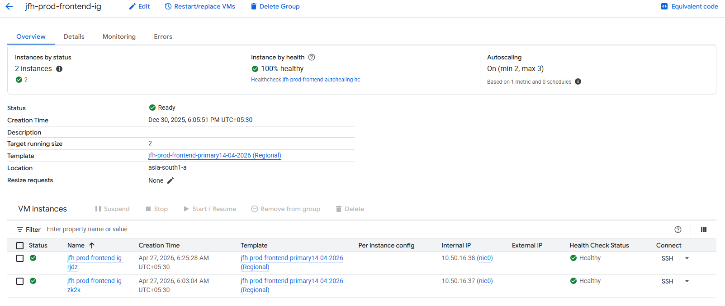

9.2 Network Configuration
VPC Network Name : herkey-vpc-prod-1
Subnet Name : herkey-private-subnet-prod-1
Connectivity Type : Private Subnet Deployment
This ensures backend instances remain within private network boundaries.

9.3. Instance Template Configuration
All virtual machines created by autoscaling use the below instance template.
Template Name: jfh-prod-frontend-primary14-04-2026
Template Scope: Regional Template
Region: asia-south1
Machine Type: e2-small
Boot Disk Size: 50 GB SSD Persistent Disk
Additional Disk Size: 100 GB SSD Persistent Disk
Firewall Access: HTTP Enabled / HTTPS Enabled
Network Tags: http-server, https-server
Instance Template – Machine Configuration:
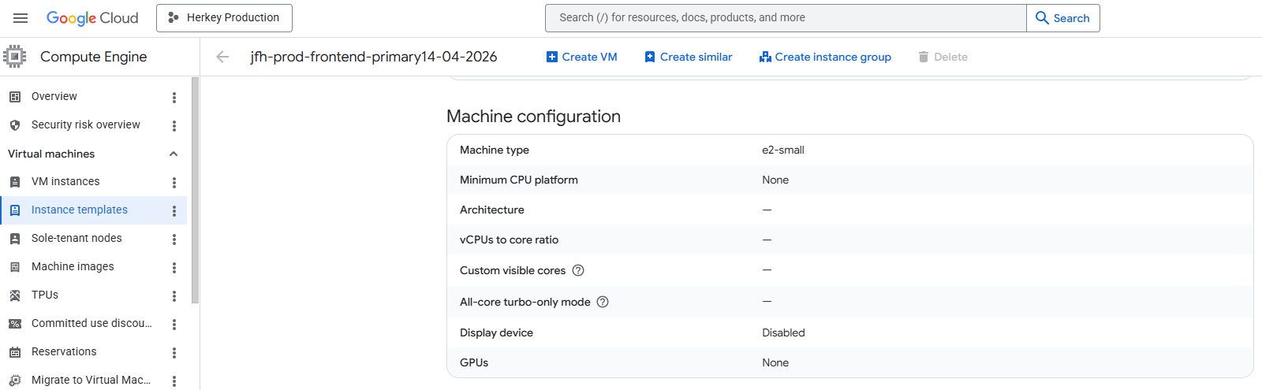
Instance Template – Storage Configuration:
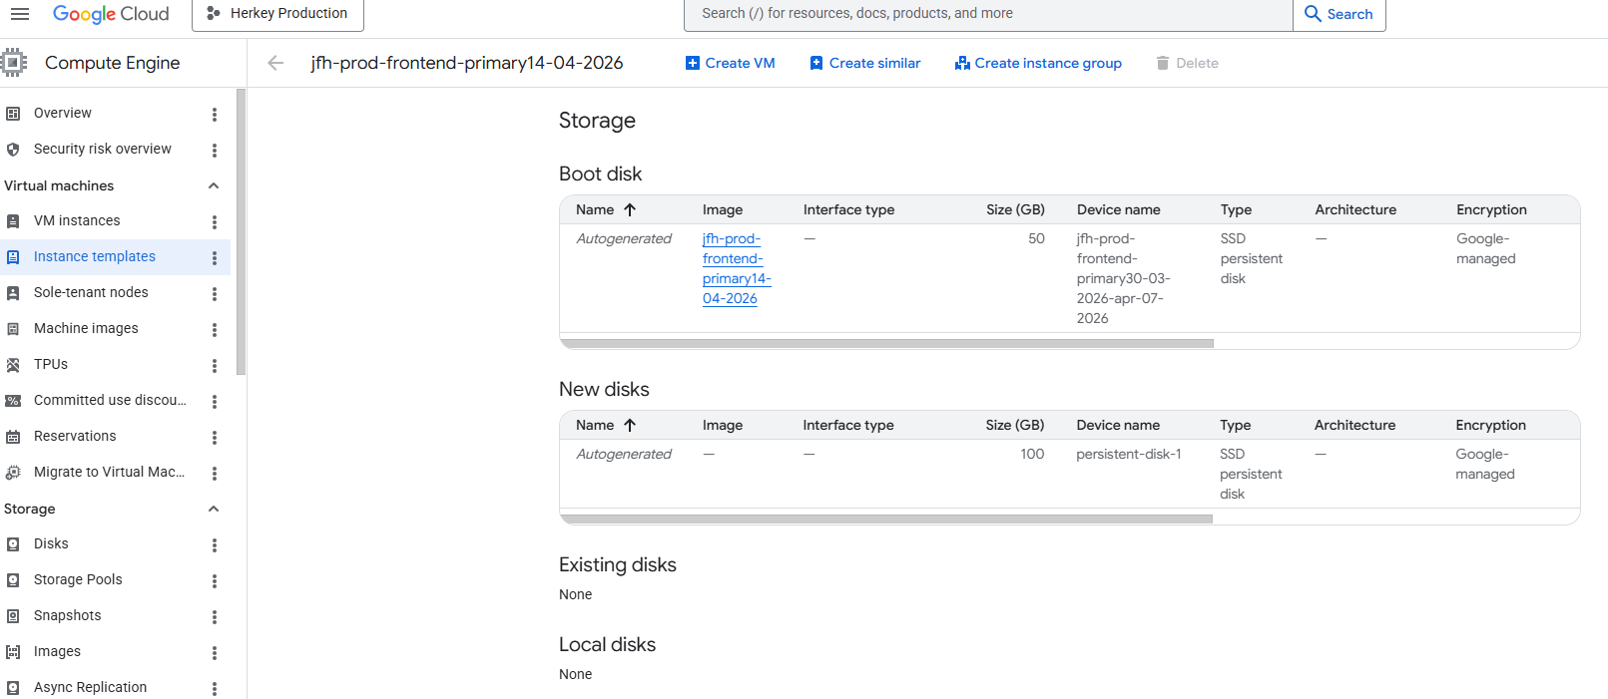
Instance Template – Firewall & Network Tags:
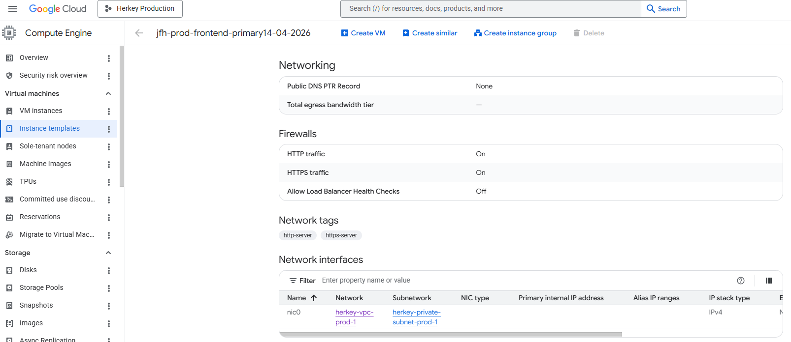

9.4. Autoscaler Configuration
Autoscaler Name: jfh-prod-frontend-ig
Autoscaler Status: ACTIVE
Scaling Mode: ON
Minimum Number of Instances: 2
Maximum Number of Instances: 3
Recommended Current Size: 2
Cooldown Period: 300 Seconds
Scaling Metric: CPU Utilization
CPU Target Threshold: 35%
Predictive Scaling Mode: OPTIMIZE_AVAILABILITY
Autoscaler Configuration:
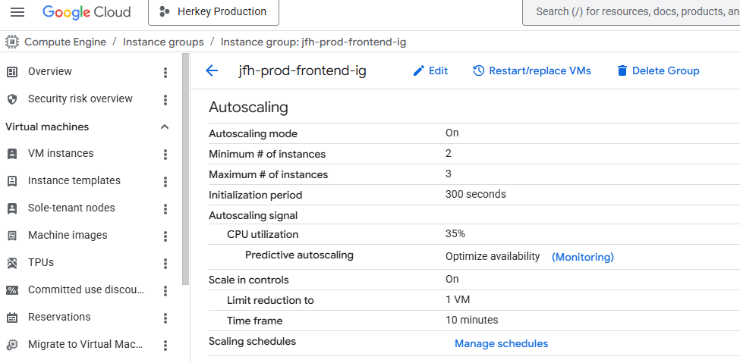

9.5. Scale-In Control Configuration
To prevent sudden reduction of instances, scale-in control has been configured.
Scale-In Time Window: 600 Seconds
Maximum Instances Removed in Window: 1
This means only one server can be removed within ten minutes, ensuring application stability.

9.6. Auto Healing Configuration
Health Check Name: jfh-prod-frontend-autohealing-hc
Initial Delay Before Health Check: 300 Seconds
Repair Action: Automatic Recreate

Functionality:
- New VM starts and gets 300 seconds warm-up time
- Health checks begin after delay
- If VM fails health check, it is recreated automatically
Health Check Configuration:
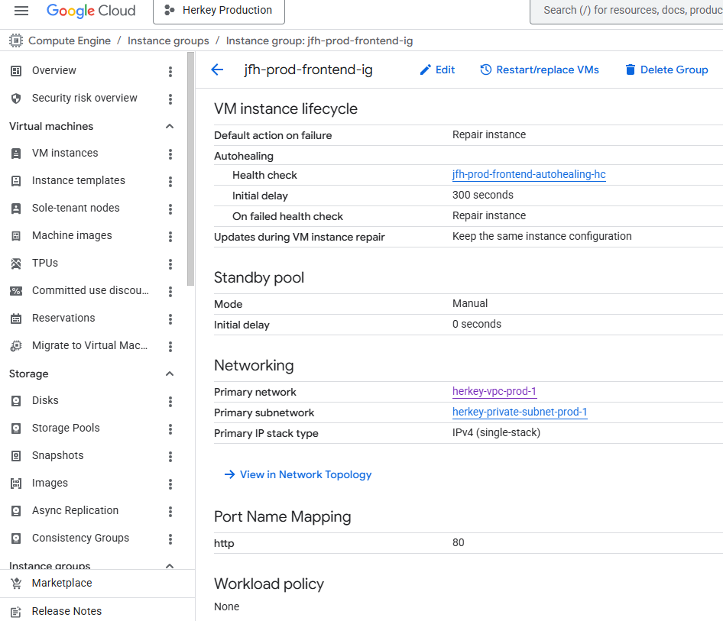

10. LOAD BALANCING

10.1 Introduction
The Load Balancer is used to distribute incoming user traffic securely across backend frontend servers hosted in the Managed Instance Group.
The current setup provides:
- External HTTPS access for public users
- SSL termination using managed certificates
- Traffic distribution to backend frontend servers
- Health-based routing
- Integration with autoscaling backend instances
- Backend security policy enforcement

10.2 Load Balancer Overview
Load Balancer Name : frontend-elb-production
Load Balancer Type : Regional External Application Load Balancer
Region : asia-south1
Network Tier : Premium
This load balancer is internet-facing and receives production user traffic over HTTPS.

10.3 Frontend Configuration
Protocol : HTTPS
Frontend IP Address : 34.93.254.102
Frontend Port : 443
Network Tier : Premium
SSL Policy : GCP Default
HTTP Keepalive Timeout : 610 Seconds
The frontend listener accepts secure HTTPS traffic and forwards requests to backend services.
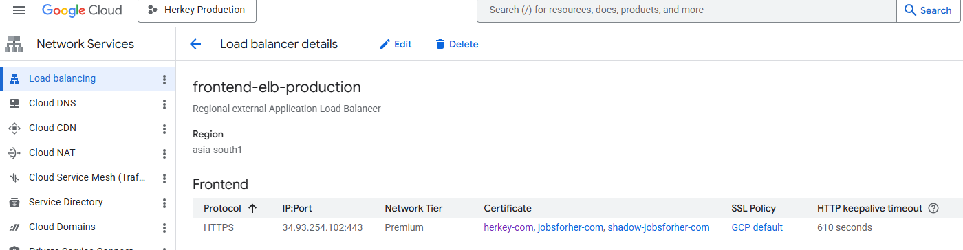

10.4 SSL Certificate Configuration
The load balancer is configured with SSL certificates for the following domains:
- herkey.com
- jobsforher.com
- shadow-jobsforher.com
This ensures encrypted communication between users and the load balancer.

10.5 Host and Path Rules
The load balancer routes traffic using host-based rules.

Current Routing Rules
Default Host Rule : All unmatched traffic
Path Rule : All unmatched paths
Backend Target : frontend-migrated-bs
Additional Host Rule : business.herkey.com
Path Rule : All unmatched paths
Backend Target : frontend-migrated-bs
This means both default traffic and business.herkey.com traffic are routed to the same backend service.
Host and Path Rules Section:
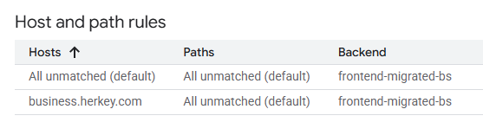

10.6 Backend Service Configuration
Backend Service Name : frontend-migrated-bs
Endpoint Protocol : HTTP
Named Port : http
Backend Timeout : 60 Seconds
IP Address Policy : IPv4 Only
Logging Status : Enabled
Sample Rate : 1
This backend service receives traffic from the load balancer and forwards requests to the Managed Instance Group.
Backend Service Configuration:
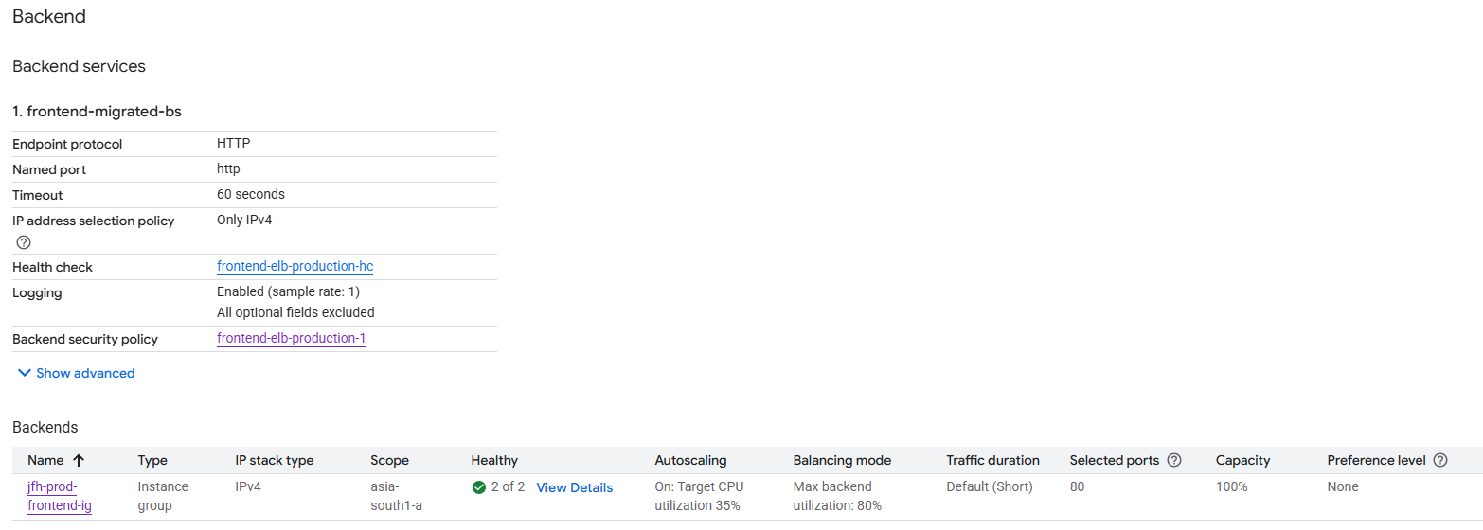

10.7 Backend Instance Group Details
Attached Backend Group : jfh-prod-frontend-ig
Backend Type : Instance Group
IP Stack Type : IPv4
Scope : asia-south1-a
Selected Port : 80
Healthy Instances : 2 of 2
Balancing Mode : Max Backend Utilization
Backend Utilization Threshold : 80%
Autoscaling Integration : Target CPU Utilization 35%
Capacity : 100%
The backend load balancer is integrated with the autoscaling Managed Instance Group.
Backend Instances / Health Status:
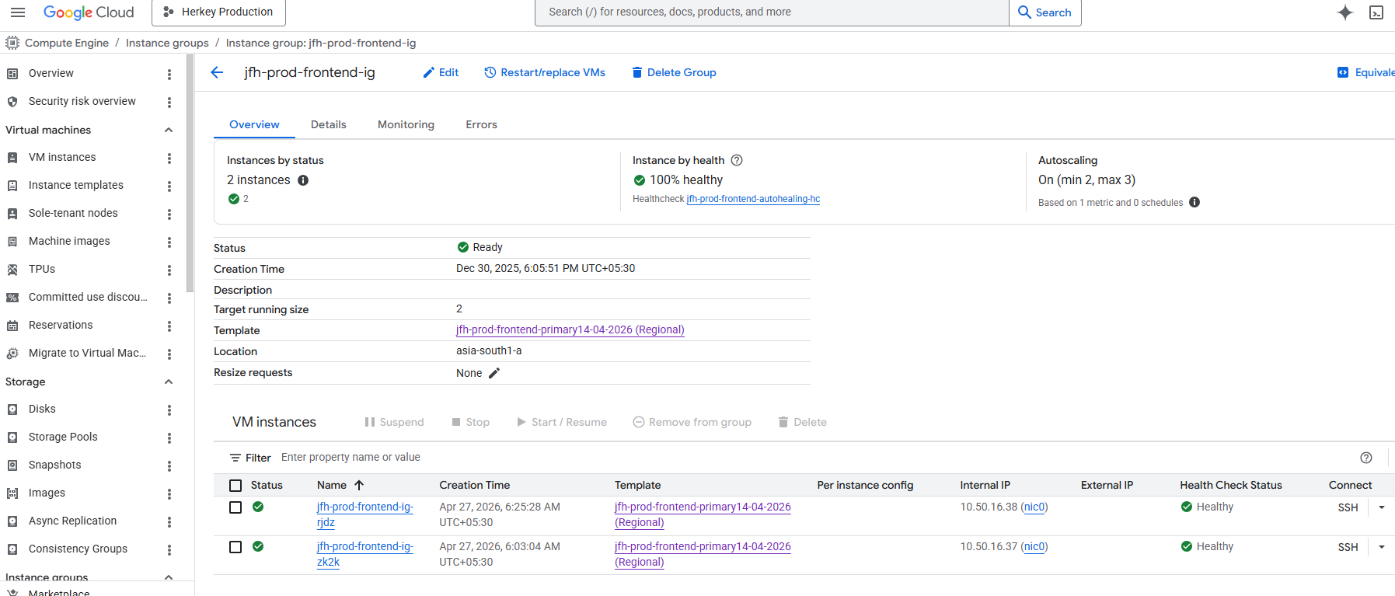

10.8 Health Check Configuration
Health Check Name : frontend-elb-production-hc
The health check monitors backend instances continuously. Only healthy instances receive production traffic.

Functionality
- Health check validates backend availability
- Unhealthy instances are removed from traffic rotation
- Recovered instances are re-added automatically
Health Check Configuration Page:
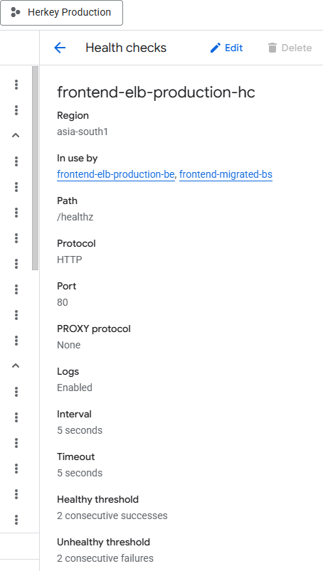

10.9 Backend Security Policy
Security Policy Name : frontend-elb-production-1
A backend security policy is attached to provide traffic filtering and protection controls.
This can be used for:
- IP allow/deny rules
- Web request filtering
- Layer 7 protection
- Threat mitigation
Backend Security Policy Section:
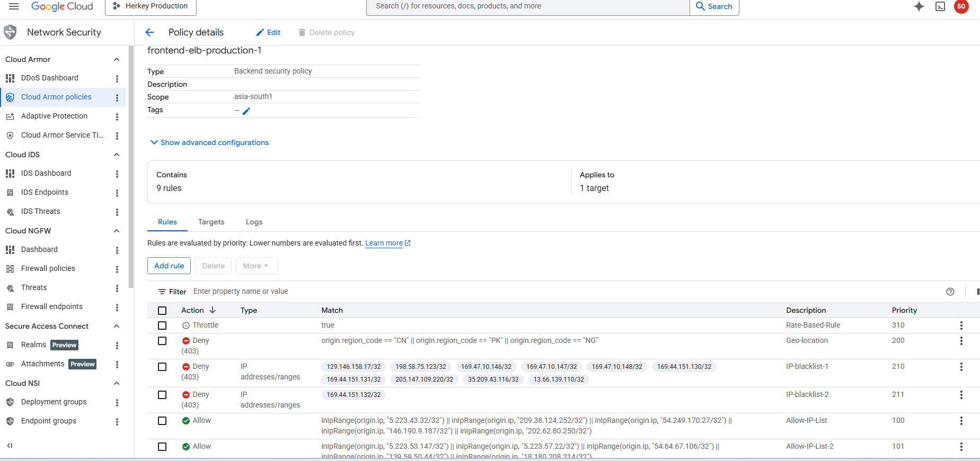
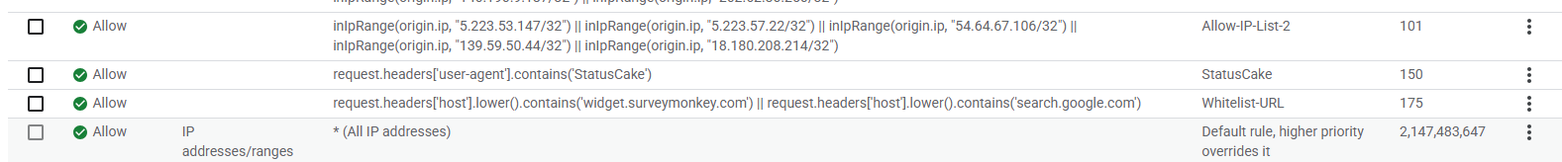

11 MONITORING AND ALERTING
Multiple alerting policies are configured using metric-based conditions.
Policy Type : Metrics Alert Policies
Status : Enabled
Configured alerts monitor:
- CPU Utilization
- Memory Utilization
- Cloud SQL CPU Usage
- VM Resource Thresholds
- Production Critical Components
Alert Policies Overview:
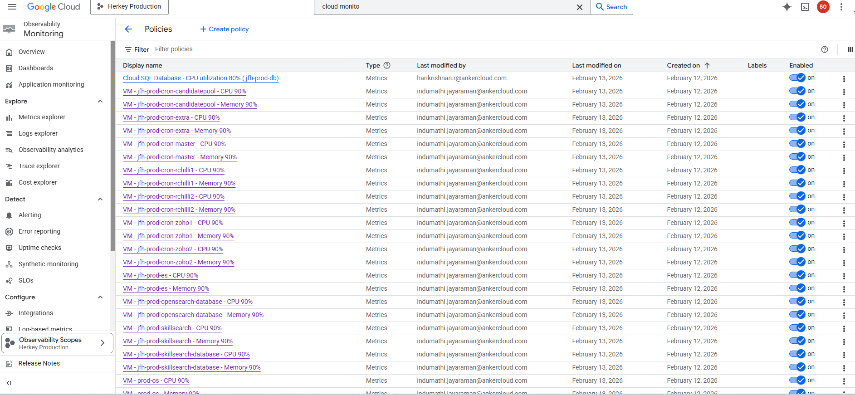

11.1 CPU Utilization Alert Policies
CPU alerts are configured for multiple production resources. Alerts trigger when CPU utilization reaches defined thresholds.

Common Thresholds Configured
CPU Threshold : 90% & 80%
Cloud SQL CPU Threshold : 90% & 80%

11.2 Memory Utilization Alert Policies
Memory alerts are configured for production virtual machines to prevent service degradation due to memory exhaustion.

Common Threshold Configured
Memory Threshold : 90% & 80%
Memory Alert Policies:
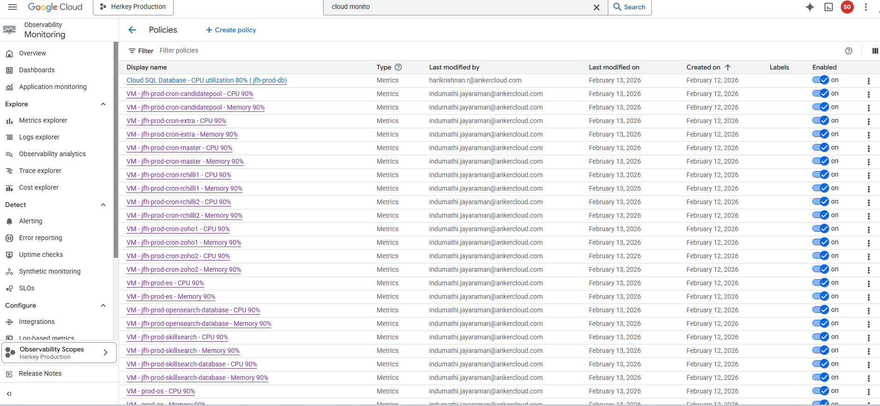

11.3 Alerting Workflow
When a monitored metric breaches configured thresholds:
- Monitoring detects abnormal behavior.
- Alert policy is triggered.
- Incident is created in Cloud Monitoring.
- Notification is sent to configured channels.
- Operations team investigates and resolves issue.
- Alert closes automatically after recovery.

11.4 Notification Channels
Notification channels are typically configured for incident communication.
Supported channels may include:
- Email Notifications
- SMS Notifications
- Webhook Integrations
- PagerDuty
- Slack / Teams (if configured)
Notification Channels Page:
